PL/SQL - Overview

The PL/SQL programming language was developed by Oracle Corporation in the late 1980s as procedural extension language for SQL and the Oracle relational database. Following are certain notable facts about PL/SQL −

* PL/SQL is a completely portable, high-performance transaction-processing language.
* PL/SQL provides a built-in, interpreted and OS independent programming environment.
* PL/SQL can also directly be called from the command-line **SQL*Plus interface**.
* Direct call can also be made from external programming language calls to database.
* PL/SQL's general syntax is based on that of ADA and Pascal programming language.
* Apart from Oracle, PL/SQL is available in **TimesTen in-memory database** and **IBM DB2**.

## **Features of PL/SQL**

PL/SQL has the following features −

* PL/SQL is tightly integrated with SQL.
* It offers extensive error checking.
* It offers numerous data types.
* It offers a variety of programming structures.
* It supports structured programming through functions and procedures.
* It supports object-oriented programming.
* It supports the development of web applications and server pages.

## **Advantages of PL/SQL**

PL/SQL has the following advantages −

* SQL is the standard database language and PL/SQL is strongly integrated with SQL. PL/SQL supports both static and dynamic SQL. Static SQL supports DML operations and transaction control from PL/SQL block. In Dynamic SQL, SQL allows embedding DDL statements in PL/SQL blocks.
* PL/SQL allows sending an entire block of statements to the database at one time. This reduces network traffic and provides high performance for the applications.
* PL/SQL gives high productivity to programmers as it can query, transform, and update data in a database.
* PL/SQL saves time on design and debugging by strong features, such as exception handling, encapsulation, data hiding, and object-oriented data types.
* Applications written in PL/SQL are fully portable.
* PL/SQL provides high security level.
* PL/SQL provides access to predefined SQL packages.
* PL/SQL provides support for Object-Oriented Programming.
* PL/SQL provides support for developing Web Applications and Server Pages.

**Question 1-** From the following tables write a SQL query to find the salesperson and customer who reside in the same city. Return Salesman, cust_name and city.

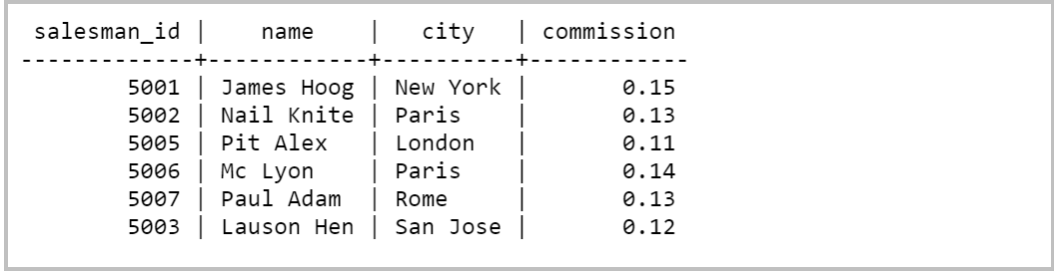

SELECT salesman.name AS "Salesman",

customer.cust_name, customer.city

FROM salesman,customer

WHERE salesman.city=customer.city;

output

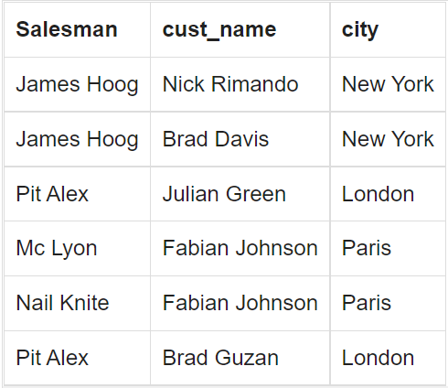

**Question 2-** From the following tables write a SQL query to find those orders where the order amount exists between 500 and 2000. Return ord_no, purch_amt, cust_name, city.

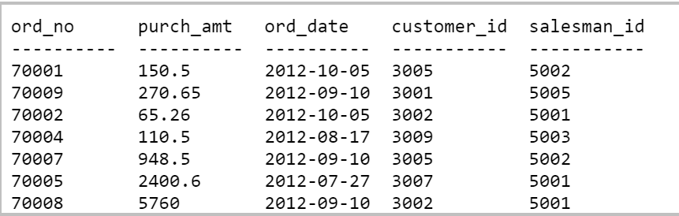

SELECT a.ord_no,a.purch_amt,

b.cust_name,b.city

FROM orders a,customer b

WHERE a.customer_id=b.customer_id

AND a.purch_amt BETWEEN 500 AND 2000;

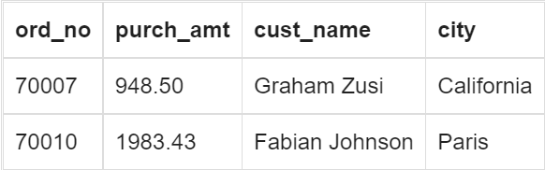

**Question 3-** From the following tables write a SQL query to find the salesperson(s) and the customer(s) he represents. Return Customer Name, city, Salesman, commission.

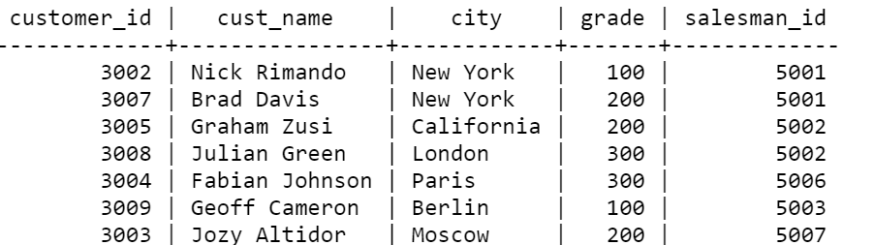

SELECT a.cust_name AS "Customer Name",

a.city, b.name AS "Salesman", b.commission

FROM customer a

INNER JOIN salesman b

ON a.salesman_id=b.salesman_id;

output

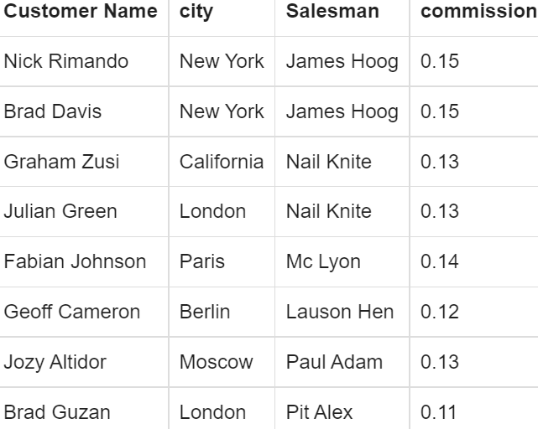

**Question 4-** From the following tables write a SQL query to find salespeople who received commissions of more than 12 percent from the company. Return Customer Name, customer city, Salesman, commission.

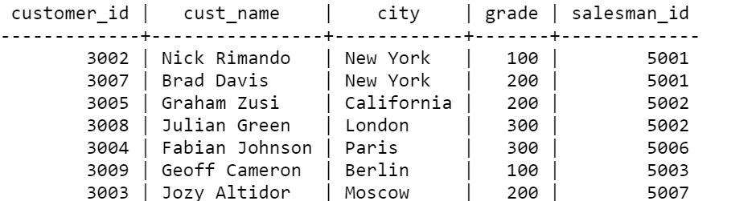

SELECT a.cust_name AS "Customer Name",

a.city, b.name AS "Salesman", b.commission

FROM customer a

INNER JOIN salesman b

ON a.salesman_id=b.salesman_id

WHERE b.commission>.12;

Output

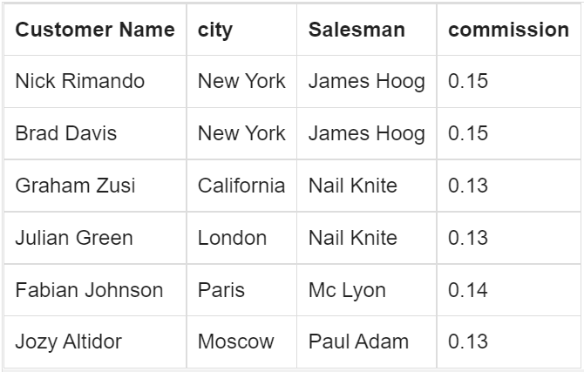

**Question 5-** From the following tables write a SQL query to locate those salespeople who do not live in the same city where their customers live and have received a commission of more than 12% from the company. Return Customer Name, customer city, Salesman, salesman city, commission.

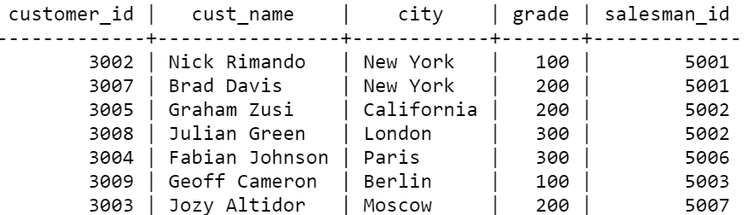

SELECT a.cust_name AS "Customer Name",

a.city, b.name AS "Salesman", b.city,b.commission

FROM customer a

INNER JOIN salesman b

ON a.salesman_id=b.salesman_id

WHERE b.commission>.12

AND a.city<>b.city;

output

